K75S Fairing Removal & Instrument Cluster Access
Disclaimer: If you follow these instructions then you do so AT YOUR OWN RISK.

This shows how to remove the right side K75S fairing. The left side is identical.

Step | Task | Picture
1 | Put bike on center stand
2 | Remove windscreen - 4 screws | 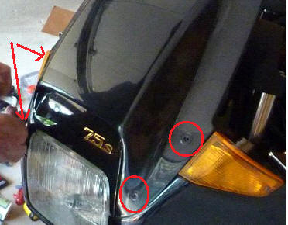
3 | Lift tip of windscreen gasket, remove screw | 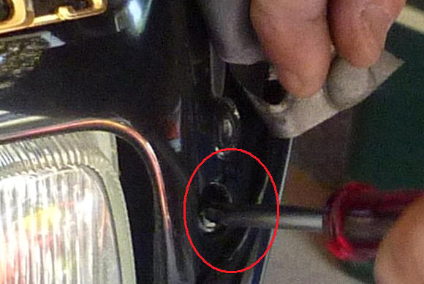
4 | Remove turn signal lens - 1 screw | 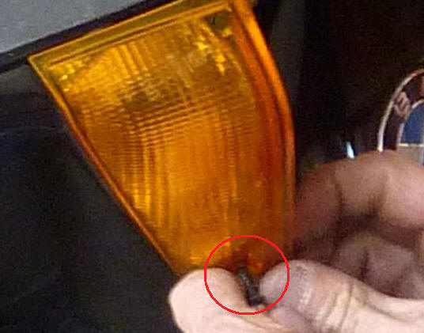
5 | Remove inside screw near the left fork | 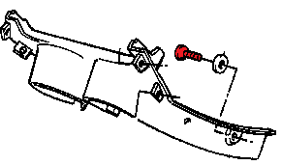
6 | Remove center screw under headlight | 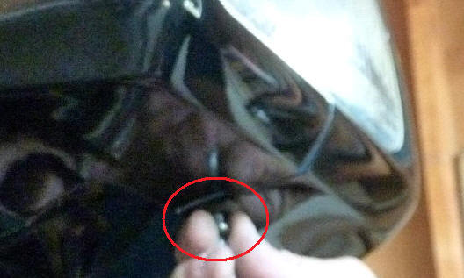
7 | Remove 2 machine screws that attach the radiator grill to the side panel. | 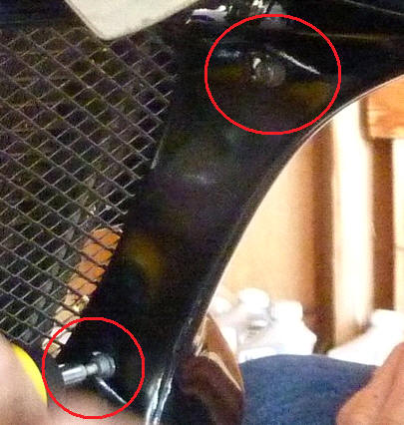
8 | Remove black plastic cover at the bottom of the fairing side panel - 1 screw | 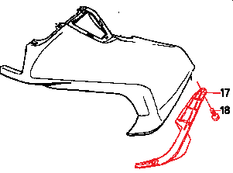
9 | At front upper corner of side panel, remove the Phillips screw in the bay behind the turn signal lens. | 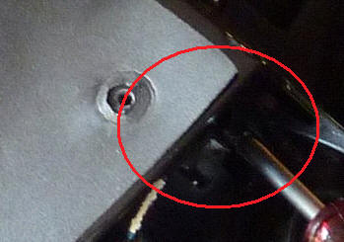
10 | Look up under where you removed the cover in Step 8 and you will see a hex bolt with a 10mm head. This bolts holds the side panel to it's bracket. Remove that bolt and the side panel comes off.
11 | Remove the two screws at the top of the headlight that hold it to the center fairing piece. Be careful not to drop the headlight. | 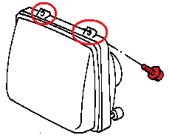
12 | Disconnect wiring harness connector for instrument cluster. For early bikes, the fastener is a Phillips screw. For later bikes, the fastener is a 3mm Allen head.
13 | Remove the four 5mm Allen head screws that hold the instrument cluster. | 